Meeting Notes Une 9, 2021
MLIB: Lisa Krebs, Brian Toth (Absent: Adele Chingee, Stephanie Rocheleau)
BC: Bryan Williams, Ryan Bichon, Loni Arman (Absent: Russ Laroche, Darcy Peel, Heather Wiebe, Janet Hughes)
ECCC: Jaspal Aulakh, Renée Lapointe, Robin Steenweg, Agathe Lebeau (Absent: Ian Parnell)
Action
Date Initiated | Action/Decision | Who | Due Date | Status
Feb 18, 2021 | Update on LUO Jan 24th PA presentation of TWG phases (Russ)  BC to touch base with Russ for an update on LUO’s | Loni to reach out to Russ for update on LUO’s |  | Ongoing
Feb 18, 2021 | Project (Parsnip KS) Work Plan  MLIB – Lisa, BC – Heather, Loni, ECCC – Renee will take to her team they have bios that would have an interest | Lisa/Heather/ Loni/Renee | “standing item” | Ongoing
Mar 17, 2021 | Revisit Renee’s paper next meeting – add as agenda item  -Is this still an interest? Will put in on the next agenda  Good to get an understanding of all Fed $$ (Thursday) | Renee | April 28
Mar 17, 2021 | We will start getting into subgroups as we dive into things look at consistency and who needs to be involved moving forward  - Loni, Brian T and Robin will work together to go through projects and start a tech group | Heather |  | Complete
Apr. 14-May 12 | BC to respond to IMA, funding work plan, G2G (not being the mechanism BC wants for agreement) and Sec 11 – 7.2 MOU.  - Bryan will provide letter prior to May 26th  - Look at March 26 work plan funding submission for components for the 7.2 MOU | Bryan W | May 26
May 12 | IYIP funding – Lisa to provide Bryan W with Jodi Ware’s contact info to share application with. Bryan to provide BC’s application which is focussed on caribou | Lisa/Bryan W | May 26
May 12 | Funding for “Hire a Tech” BC needs to step back and understand further – Loni to talk with COLT and Science Leads. Understand the difference | BC | June 9
May 12 | IYIP – Lisa to provide Jodi Ware’s contact info to Bryan W  Bryan W to provide BC’s application to MLIB (to show linkages to caribou) | MLIB/BC | May 26
May 12 | Project – Analyze DNA – understand if this is being completed already. Loni to talk with Doug and Kathi – Robin to talk with ECCC | Loni/Robin | June 9
May 12 | Estimated costs for Ethnographers | Lisa | June 9
May 12 | Funding has been provided by BC – Loni to provide report to MLIB | Loni | May 26 | Complete
May 12 | All parties need to review draft IMA and all comments/emails from previous group | All | May 26

Project Discussion:
History: 1992 in Kennedy Siding, first time it was counted and distribution recognized from Gov. realized how volunerable they were. Went to MLIB and asked what they thought, agreed that caribou shouldn’t be hunted there so MLIB put up sign to not shoot caribou. On KS road not on highway. Since specifically with SF 8 yrs ago met with Alec Chingee and described what he wanted to do and how to do it so Alec arranged for an employee to feed. Worked together to design feeders and MLIB built them. Arranged for it as a job, a contractual agreement. Personal changed now Tanya Solonas has sometime had difficultly to find work but have always found someone. Doug goes every year to give presentations to community. Annual reports are sent to MLIB as well. Also participated in school Program with elders and Mack community members in the fall. Also have looked for other sources of funding – Province has funded every year but looked to extend or increase hiring.
KS feeders have pelleted food 2 KM off of highway provide food to increase growth rate of population. Tithonus Research. Caribou arrive September and throughout rut and most arrive by Nov 1st to the middle of January then go up to old friend mnt and other areas around 25 KM n/ne. 2015 had 49 and 2021 98 so more arriving everyyear. Now they are quite approachable – they always leave when stop feeding and past year most left before stopped feeding. ID’s every animal every year from antlers.
2015 first year and numbers did not decline compared with Quinteette that continued to decline. 2020 wolf removal both herds started increasing – compare growth rate between herds feeding appeared to increased the growth rate by 8% a year at KS. This year appeared to be odd movement of caribou which suggests that all caribou are not staying in their ranges. They are also weighed every animal every year or try but some tech difficulties can see weight by age and sex… 2020-2021 all heavier then past years and females about 11 % heavier could be because of cool winter. Could see visible ribs in the fall – at this time of year should be fat. Could see why feeding increased. SAlos compared to Klinse-za but the skinny ones weighed less then average in Spring in KZ.
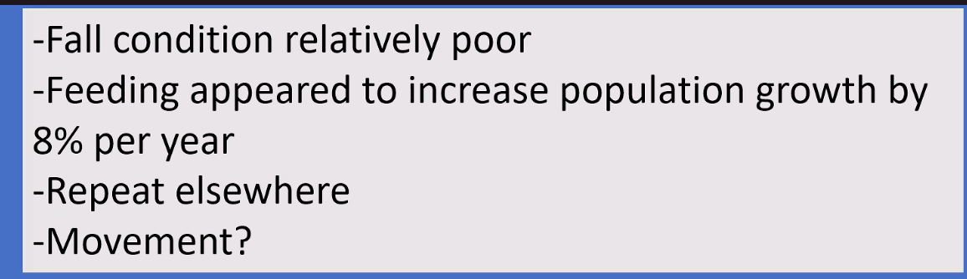
Feeding quite low cost compared to wolf and mat penning.

Questions: BT: Do we have info of pops that are unfed but have wolf management? Curious if you can tease out feeding relative to others? Did with Quintette the effect of feeding appeared to be 8%. Compared with KZ for Wolf/mat pen – those results aren’t available yet but it looks like it is about the same as feeding – growing at rate similar to KS. Can also compare 3 herds to other herds with no treatments. In a sense all treatments go together to recovery caribou.
BT is the timing unique to KS or is there other herds that show when they come low? Essentially all come low in Fall to pine flats it varies a little a bit but they come because comes first to high and hard to walk through so those caribou at subalpine doesn’t support weight so they move to where they can get food. Thing that has changed is the increase in Moose and wolve numbers started feeding initially because caribou changed behaviour in spring to stay high. By providing food in fall they still have appetite but in winter they don’t eat as much.
Renee – have you encountered issues with predators with the stations? Yes there are a lot of camaras have photod all potential few wolves lots of Grizzly and some black bears. There has been no actal predation we know that because we have a 96 % survival rate. It doesn’t look like feeders increase volunarablity, in general all survive pretty well predation is a rare event. The decline is long term continuous year after year decline.
Is there a way to do feeding in other areas by like helicopters or something. Doug’s original proposal… A lot of herds have collars so if we wanted to feed we could. At high elevation in Spring time you can put food on snow cause it is cold… Issue is cost because of using heli over driving… It still wouldn’t be as expensive as other things like wolf removal
Robin – where is elsewhere? On pops already trained with food.. like Klinse za caribou most are still free ranging and have been in pen before so they are already trained in food. Want to try it in the Spring (has changed spring access to food). Best to try with smaller pop that are declining like Takla, Telkwa etc.
Doesn’t think it changes their volunertabilty if at higher elevation wolves not usually there. Not necessarily need wolf contro; would like to replicate in area with out wolf control.
BT given what we know about Parsnip and option there?
Yes but talking a much larger area. So if we wanted to refine technique and choose one area such as anzak but would only be feeding only a third of pop so just looking at technique unless wanted to go over the entire range which would be expensive.
Seeing movements that were unexpected – why? We don’t have good explanation – very little variation between bulls/cows and estimate survival.. Had a lot of extra bulls this year and more that could have been counted for. Scott also had lots of bulls. Maybe they are ranging more widely but we don’t know why. There were fewer cows this year and more calves. One cow went to the Hart Ranges all cows with collar stayed on their ranges.. Looks like some movement but haven’t nailed it down. Suggests non-traditional movement to Kennedy siding.
First thing keep feeding then try to learn as much as we can about caibou conservation and management so more study.
DNA: Doug
- Trying to figure out movements as we would know where their parents are. We would like DNA from every animal every year to track survival and age. Age is impact in survival reproduction.
Look at movements survival inbreeding could be important elsewhere. The collection is straight forward it is the labe people that need to analyze them.
The Snot snares are another way. Doug has few samples form previous years last year got 65 %. Anticipating we can get 100% with more effort.
MLIB new they were there road was there since reservoir - community said that we don’t want to shoot the caribou.
Got ethnographers doing work at MLIB.
Lisa struggling with context between relationship of MLIB with Caribou. In wolverine herd a long history of MLIB exercising their T8 rights because moose relatively new to MLIB. Oral history caribou primary source of of protein. Caution in talking in relationships with caribou recognizing have a recent perspective.
Complicated relationship between moose and caribou.
Context of S35 rights and ability to practice. Some managers saying there are still animals so ok but not understanding of what meaningfully means.
What is the food? Pellated ration developed at Un in Alaska. At first caribou didn’t really like it now they are quite interested in it.
Broader Research Program: Doug

Hormones and Nutrition: Heather B
Continuing on from Dougs presentation. Small part of larer research program to better undstand link of feeding with pop increase. Wildlife health and physiology background. Trying to better understand mechanisms linking feeding to pop data.
So far data shows there is a pop response to feeding buy don’t know much atf mechanism is improved nutrition enable females to produce stronger calves or does it increase propotion of cows to breed.
Is it more beneficial in spring or fall?
Study objectives: reconstruct the reproductive histories of female caribou to determine if females without calves lost their calves or failed to become pregnant – can we figure out which females had a clve and lost compared to if they just didn’t reproduce
Compare ovarian cyclies during the breeding season in femails with low vx high body condition to better understand the link between nutritional condition and pregnancy rates – would support alternate yr breeding
Examin hormonal profiles related to nutrition in pellet samples to evaluate changes in the nutritional status of femails in response to feeding (cordosol thyroid)
Collect hair and pellet samples at feeding over time. Hair can provide info on hormones.
Pellets representative a caribou’s reproductive and nutruiciton physiology over past 24-72 hrs – do females have stronger ovarian cyles suggesting they are more likely to get pregnant
If yes hypotheses suggest proviging food in spring may help them to get pregnant
Are ther changes in physiology during feeding period? Difficult to get all info because of problems with scale.
Feedubg earlier in year may be beneficial in relation in reproduction.
Better understand in effects of supp feeding on reproduction and recruitment (alternate year vs poor calf survival.
Links: will occur as part of feeding in fall of 21-22
Hair an pellet samples could be used for DNA sampling
Costs of sameple analysis so DNA cost not covered.
Work with MLIB:
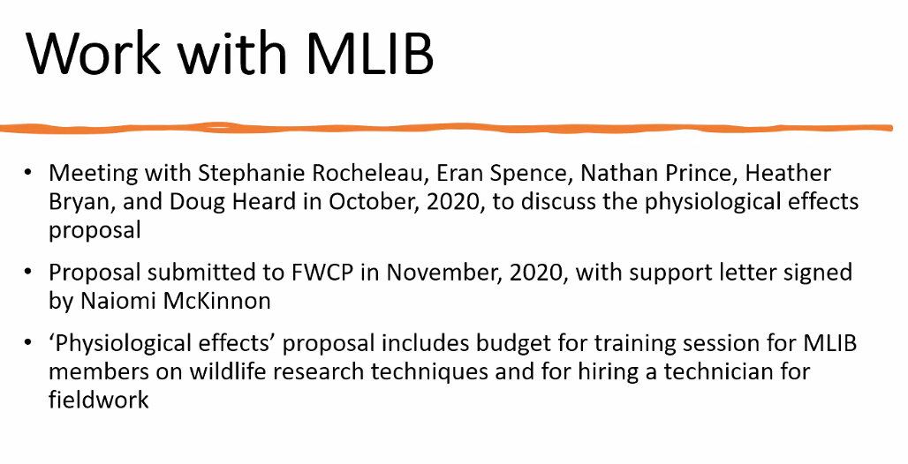
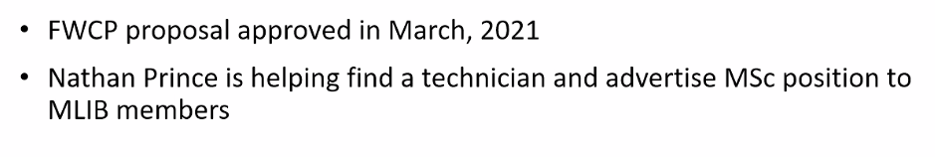
Is there a control aspect with other pops without supp feeding? Do not have a controlled pop for this. Have talked with WI to use some of there samples with known reproductinve histories…
BT: Looking to scope some draft ideas for guardian would work well with Heather’s training opportunity.
Agathe L: ECCC has funding to provide for project for MLIB participation and science. Have approval to provide 60,000 for next two years 120 total. Very interested in science questions and having MLIB continue to participate Through Indi partnership initiative. Enough flexibility in workplan to have outreach components to be different things such as hiring of tech or even community event info session, education, including people increase
RS ECCC already paying for samples to be analyzed… Only collared animals.
Canada supportive of this.
Next Steps: All
- Need money to analyze samples
- Funding to acquire a tech for more time but most money to analysis
- Doug concern need to get appropriate people from MLIB to get people involved and are keen need to find person best suited – LK working with Tanya is a more a direct community interface. But sometimes the level of work is hard to fill (like seasonal etc). Can be challenging keep it at Tanya. Need to recruit people got to bring in right person. BT will bring to internal group to ask if Tanay is right person. One of the objectives wondering what can we add to feeding etc like guardian

